Introduction:

Before presenting more applications, the terms ‘mobile’ and ‘wireless’ as used we need to know about the aspects of mobility(the ability to move ).

* **User mobility:** users communicate (wireless) “anytime, anywhere, with anyone”. User mobility refers to a user who has access to the same or similar telecommunication services at different places, i.e., the user can be mobile, and the services will follow him or her. Examples for mechanisms supporting user mobility are simple call-forwarding solutions known from the telephone or computer desktops supporting roaming.
* **Device portability**: The communication device moves (with or without a user). Many mechanisms in the network and inside the device have to make sure that communication is still possible while the device is moving. A typical example for systems supporting device portability is the mobile phone system.

The term **wireless**describes the way of accessing a network or other communication partners, i.e., without a wire. The wire is replaced by the transmission of electromagnetic waves through ‘the air’ (although wireless transmission does not need any medium). A communication device can thus exhibit one of the following characteristics:

● **Fixed and wired**: This configuration describes the typical desktop computer in an office. Neither weight nor power consumption of the devices allow for mobile usage. The devices use fixed networks for performance reasons.

● **Mobile and wired**: Many of today’s laptops fall into this category; users carry the laptop from one hotel to the next, reconnecting to the company’s network via the telephone network and a modem.

● **Fixed and wireless**: This mode is used for installing networks, e.g., in historical buildings to avoid damage by installing wires, or at trade shows to ensure fast network setup. Another example is bridging the last mile to a customer by a new operator that has no wired infrastructure and does not want to lease lines from a competitor.

● **Mobile and wireless**: This is the most interesting case. No cable restricts the user, who can roam between different wireless networks. Most technologies discussed in this book deal with this type of device and the networks supporting them. Today’s most successful example for this category is GSM with more than 800 million users.

Applications:

* **Vehicles:**

Cars will comprise many wireless communication systems and mobility aware applications. Music, news, road conditions, weather reports, and other broadcast information are received via **digital audio broadcasting (DAB) with 1.5 Mbit/s**. For personal communication, **a universal mobile telecommunications system (UMTS)** phone might be available offering voice and **data connectivity with 384 k bit/s**. For remote areas, satellite communication can be used, while the current position of the car is determined via **the global positioning system (GPS**). Cars driving in the same area build a local **ad-hoc network** for the fast exchange of information in emergency situations or to help each other keep a safe distance. In case of an accident, not only will the airbag be triggered, but the police and ambulance service will be informed via an emergency call to a service provider.

Networks with a fixed infrastructure like cellular phones (GSM, UMTS) will be interconnected with **trunked radio systems (TETRA)** and wireless LANs (WLAN). Satellite communication links can also be used. The networks between cars and inside each car will more likely work in an ad-hoc fashion. Wireless pico networks inside a car can comprise **personal digital assistants (PDA)**, laptops, or mobile phones, e.g., connected with each other using the **Bluetooth technology**.

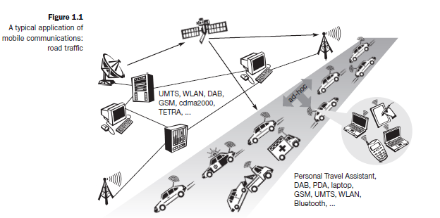

* **Emergencies**

Just imagine the possibilities of an ambulance with a high-quality wireless connectionto a hospital. Vital information about injured persons can be sent to thehospital from the scene of the accident. All the necessary steps for this particulartype of accident can be prepared and specialists can be consulted for an earlydiagnosis. Wireless networks are the only means of communication in the caseof natural disasters such as hurricanes or earthquakes. In the worst cases, onlydecentralized, wireless ad-hoc networks survive. The breakdown of all cablingnot only implies the failure of the standard wired telephone system, but also thecrash of all mobile phone systems requiring base stations!

* **Business**

A travelling salesman today needs instant access to the company’s database: toensure that files on his or her laptop reflect the current situation, to enable thecompany to keep track of all activities of their travelling employees, to keep databasesconsistent etc. With wireless access, the laptop can be turned into a truemobile office, but efficient and powerful synchronization mechanisms are needed.Gas stations may offerWLAN hot spots as well as gas. Trains already offer support for wireless connectivity. Several more handovers to different technologies might be necessary before reaching the officeto ensure data consistency.

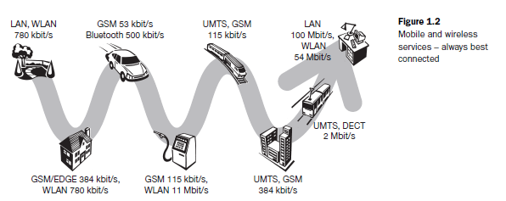

* **Replacement of wired networks**

In some cases, wireless networks can also be used to replace wired networks, e.g., remote sensors, for tradeshows, or in historic buildings. Due to economicreasons, it is often impossible to wire remote sensors for weather forecasts, earthquake detection, or to provide environmental information. Wireless connections,e.g., via satellite, can help in this situation. Tradeshows need a highlydynamic infrastructure, but cabling takes a long time and frequently proves tobe too inflexible. Many computer fairs use WLANs as a replacement for cabling.Other cases for wireless networks are computers, sensors, or information displaysin historical buildings, where excess cabling may destroy valuable walls orfloors. Wireless access points in a corner of the room can represent a solution.

* **Infotainment and more**

**Infotainment** generally refers to broadcast material which is intended both to entertain and to inform.Wireless networks can provide up-to-date information at any appropriate location (static data +dynamic updated content). The travel guide might tell you something about the history of a building (knowing via GPS, contact to a local base station, or train where you are) downloading information about a concert in thebuilding at the same evening via a local wireless network. You may choose aseat, pay via electronic cash, and send this information to a service provider.

* **Location dependent services**

It is important for an application to ‘know’ something about the location or the user might need location information forfurther activities. Several services that might depend on the actual location canbe distinguished

* **Follow-on services**: The function of forwarding calls to the current userlocation is well known from the good old telephone system. Wherever youare, just transmit your temporary phone number to your phone and it redirectsincoming calls. That is services will be followed from one to one based on requirement.
* **Location aware services:** Imagine you wanted to print a document sittingin the lobby of a hotel using your laptop. If you drop the document overthe printer icon, where would you expect the document to be printed? Certainly not by the printer in your office! However, without additionalinformation about the capabilities of your environment, this might be theonly thing you can do. For instance, there could be a service in the hotelannouncing that a standard laser printer is available in the lobby or acolor printer in a hotel meeting room etc. Your computer might then transmityour personal profile to your hotel which then charges you with theprinting costs.
* **Privacy:**

There might be locations and/or times when you want to exclude certain services fromreaching you and you do not want to be disturbed. You want to utilize locationdependent services, but you might not want the environment to know exactly who you are. All these issues are comes under privacy.

* **Information services:**

**‘pull’** information from a service, e.g., ‘Where is the nearest Mexican restaurant?’ However, a service could also actively**‘push’** information on your travel guide, e.g., the Mexican restaurant justaround the corner has a special taco offer.

* **Support services**: Many small additional mechanisms can be integrated tosupport a mobile device. Intermediate results of calculations, state information,or cache contents could ‘follow’ the mobile node through the fixednetwork. As soon as the mobile node reconnects, all information is availableagain. This helps to reduce access delay and traffic within the fixednetwork. Caching of data on the mobile device (standard for all desktopsystems) is often not possible due to limited memory capacity. The alternativewould be a central location for user information and a user accessingthis information through the (possibly large and congested) network all thetime as it is often done today.
* **Mobile and wireless devices:**
* **Sensor**: A very simple wireless device is represented by a sensor transmittingstate information. A device which detects or measures a physical property and records, indicates, or otherwise responds to it.Eg: **humidity**, speed, etc. can be found using sensors.
* **Embedded controllers:** Many appliances already contain a simple or sometimesmore complex controller. Keyboards, mice, headsets, washing machines, coffee machines, hair dryers and TV sets are just some examples. (i.e receiving processing or other types of signals from other devices and performing on our system)
* **Pager**: As a very simple receiver, a pager can only display short text messages,has a tiny display, and cannot send any messages (or) A pager is a small telecommunications device that receives (and, in some cases, transmits) alert signals and/or short messages.
* **Mobile phones:** A mobile phone is a wireless handheld device that allows users to make calls and send text messages, among other features.
* **Personal digital assistant**: PDAs typically accompany a user and offersimple versions of office software (calendar, note-pad, mail). It is also known as handheld PC.
* **Pocket computer:** The next steps toward full computers are pocket computers offering tiny keyboards, color displays, and simple versions of programs found on desktop computers (text processing, spreadsheets etc.).
* **Notebook/laptop**: Laptops offer more or less the same performanceas standard desktop computers; they use the same software – the only technical difference being size, weight, and the ability to run on a battery.

**Effects of device portability:**

* Power consumption

Limited computing power, low quality displays, small disks due to limited battery capacity

CPU: power consumption ~ CV2f

* C: internal capacity, reduced by integration
* V: supply voltage, can be reduced to a certain limit
* f: clock frequency, can be reduced temporally
* Loss of data

Higher probability, has to be included in advance into the design (e.g., defects, theft)

* Limited user interfaces

Compromise between size of fingers and portability

Integration of character/voice recognition, abstract symbols

* Limited memory

Limited value of mass memories with moving parts

Flash-memory as alternative but it was limited.

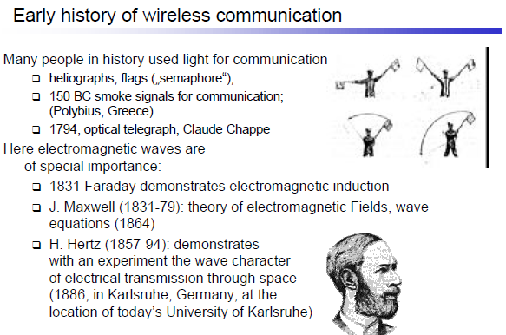

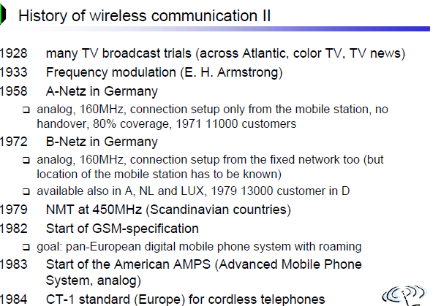

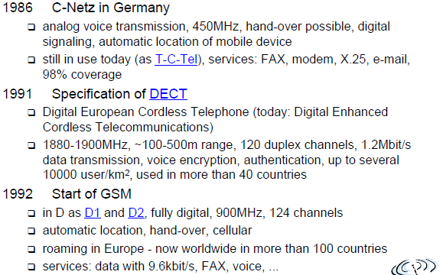

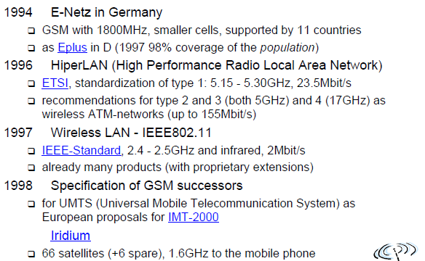

**A market for mobile communications**

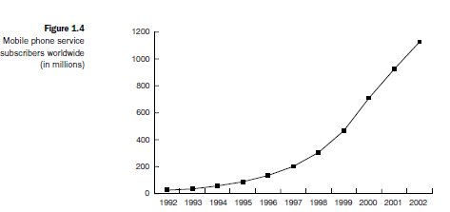

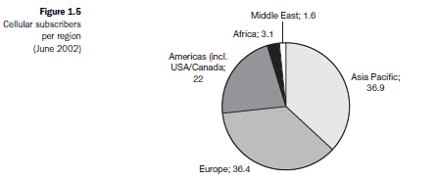

**Simple reference model:**

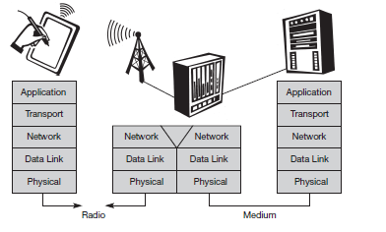

● **Physical layer**: This is the lowest layer in a communication system and is responsible for the conversion of a stream of bits into signals that can be transmitted on the sender side. The physical layer of the receiver then transforms the signals back into a bit stream. For wireless communication, the physical layer is responsible for frequency selection, generation of the carrier frequency, signal detection (although heavy interference may disturb the signal), modulation of data onto a carrier frequency and (depending on the transmission scheme) encryption.

● **Data link layer:** The main tasks of this layer include accessing the medium, multiplexing of different data streams, correction of transmission errors, and synchronization (i.e., detection of a data frame). The data link layer is responsible for a reliable point-to-point connection between two devices or a point-to-multipoint connection between one sender and several receivers.

● **Network layer**: This third layer is responsible for routing packets through a network or establishing a connection between two entities over many other intermediate systems. Important topics are addressing, routing, device location, and handover between different networks.

Solutions for the network layer protocol of the internet (the Internet Protocol IP).

● **Transport layer:** This layer is used in the reference model to establish an end-to-end connection*.* Topics like quality of service, flow and congestion controlare relevant, especially if the transport protocols known from the Internet, TCP and UDP, are to be used over a wireless link.

● **Application layer:** Finally, the applications (complemented by additional layers that can support applications) are situated on top of all transmission oriented layers. Topics of interest in this context are service location, support for multimedia applications, adaptive applications that can handle the large variations in transmission characteristics, and wireless access to the world-wide web using a portable device. Very demanding applications are video (high data rate) and interactive gaming (low jitter, low latency).

2.1 Frequencies for radio transmission:

Radio transmission can take place using many different frequency bands. Each frequency band exhibits certain advantages and disadvantages. The ﬁgure shows frequencies starting at 300 Hz and going up to over 300 THz. Directly coupled to the frequency is the wavelength λ via the equation:

λ = c/f,

where c ≅ 3·108 m/s (the speed of light in vacuum) and f the frequency.

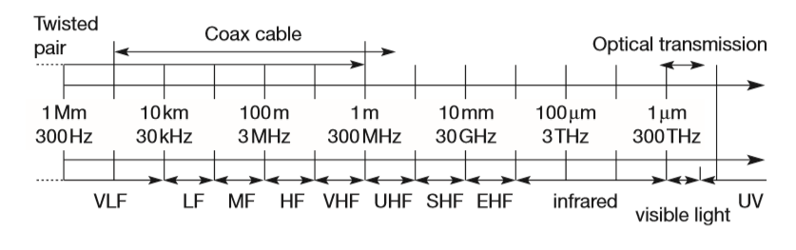

For traditional wired networks, frequencies of up to several hundred kHz are used for distances up to some km with twisted pair copper wires, while frequencies of several hundred MHz are used with coaxial cable (new coding schemes work with several hundred MHz even with twisted pair copper wires over distances of some 100m). Fiber optics are used for frequency ranges of several hundred THz, but here one typically refers to the wavelength which is, e.g., 1500 nm, 1350 nm etc. (infra-red).

               Radio transmission starts at several kHz, the very low frequency (VLF) range. These are very long waves. Waves in the low frequency (LF) range are used by submarines, because they can penetrate water and can follow the earth’s surface. Some radio stations still use these frequencies, e.g., between 148.5 kHz and 283.5 kHz in Germany. The medium frequency (MF) and high frequency (HF) ranges are typical for transmission of hundreds of radio stations either as amplitude modulation (AM) between 520 kHz and 1605.5 kHz, as short wave (SW) between 5.9 MHz and 26.1 MHz, or as frequency modulation (FM) between 87.5 MHz and 108 MHz. The frequencies limiting these ranges are typically fixed by national regulation and, vary from country to country. Short waves are typically used for (amateur) radio transmission around the world, enabled by reflection at the ionosphere. Transmit power is up to 500 kW – which is quite high compared to the 1 W of a mobile phone.

Conventional analog TV is transmitted in ranges of 174–230 MHz and 470–790 MHz using the very high frequency (VHF) and ultra-high frequency (UHF) bands. In this range, digital audio broadcasting (DAB) takes place as well (223–230 MHz and 1452–1472 MHz) and digital TV is planned or currently being installed

Super high frequencies (SHF): are typically used for directed microwave links (approx. 2–40 GHz) and fixed satellite services in the C-band (4 and 6 GHz), Ku-band (11 and 14 GHz), or Ka-band (19 and 29 GHz).

Extremely high frequency (EHF):range which comes close to infra-red. All radio frequencies are regulated to avoid interference, e.g., the German regulation covers 9 kHz–27

Infra-red (IR): transmission is used for directed links, e.g., to connect different buildings via laser links. The most widespread IR technology, infra-red data association (IrDA), uses wavelengths of approximately 850–900 nm to connect laptops, PDAs etc.

** Signals**:

Signals are the physical representation of data. Users of a communication system can only exchange data through the transmission of signals. Layer 1 of the ISO/OSI basic reference model is responsible for the conversion of data, i.e., bits, into signals and vice versa.

Signals are functions of time and location. Signal parameters represent the data values. The most interesting types of signals for radio transmission are periodic signals, especially sin waves as carriers.

                                    g(t) = At sin(2 πft t + φt)

Signal parameters are the amplitude A, the frequency f, and the phase shift φ.Basically there are two types of data

> Digital {no parameters} and it is a discrete signal that is value is located a particular position.

> Analog signals {amplitude, frequency and phase are the parameters} .It is a continuous signal i.e values are present at all locations.

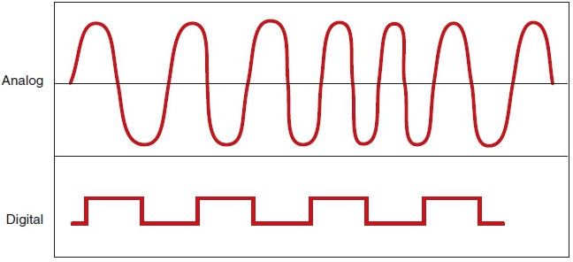

Where Amplitude defines the maximum length of the analog wave.

Frequency defines how many cycles are completed by the analog wave in unit time period.

Phase describes the relative position of the wave

* Periodic signals repeats at a constant interval of time.

|  |
| --- |
| Is the Fourier representation of the signal. |

**Antennas**:

We do not need any ‘medium’ (such as an ether) for the transport of electromagnetic waves. Somehow, we have to couple the energy from the transmitter to the outside world and, in reverse, from the outside world to the receiver. This is exactly what antennas do.

In radio and electronics, an antenna (plural antennae or antennas), or aerial, is an electrical device which converts electric power into radio waves, and vice versa. It is usually used with a radio transmitter or radio receiver.

A theoretical reference antenna is the **isotropic radiator**, a point in space radiating equal power in all directions, i.e., all points with equal power are located on a sphere with the antenna as its center.

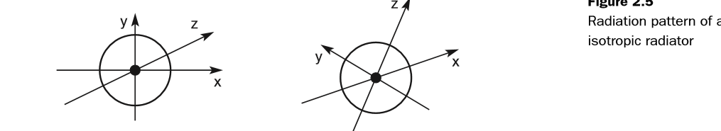

The radiation pattern is symmetric in all directions. However, such an antenna does not exist in reality. **Real antennas** all exhibit directive effects, i.e., the intensity of radiation is not the same in all directions from the antenna. The simplest real antenna is a thin, center-fed dipole, also called Hertzian dipole, as shown in Figure

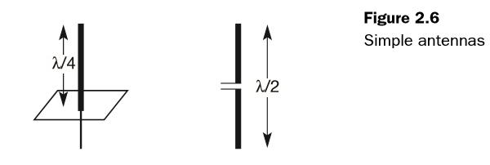

The dipole consists of two collinear conductors of equal length, separated by a small feeding gap. The length of the dipole is not arbitrary, but, for example, half the wavelength λ of the signal to transmit results in a very efﬁcient radiation of the energy. If mounted on the roof of a car, the length of λ/4 is efﬁcient. This is also known as **Marconi antenna**.

A λ/2 dipole has a uniform or omni (all) -directional radiation pattern in one plane and a ﬁgure eight pattern in the other two planes. This type of antenna can only overcome environmental challenges by boosting the power level of the signal. Challenges could be mountains, valleys, buildings etc.

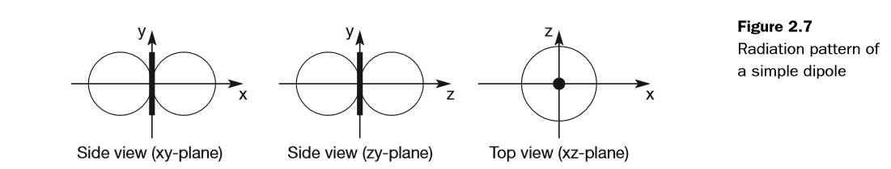

If an antenna is positioned, e.g., in a valley or between buildings, an omnidirectional radiation pattern is not very useful. In this case, directional antennas with certain fixed preferential transmission and reception directions can be used.

Figure 2.8 shows the radiation pattern of a directional antenna with the main lobe in the direction of the x-axis. A special example of directional antennas is constituted by satellite dishes.

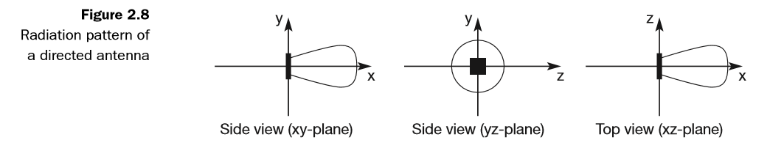

Directed antennas are typically applied in cellular systems as presented in section 2.8. Several directed antennas can be combined on a single pole to construct a sectorized antenna.

A cell can be sectorized into, for example, three or six sectors, thus enabling frequency reuse as explained in section 2.8. Figure 2.9 shows the radiation patterns of these sectorized antennas.

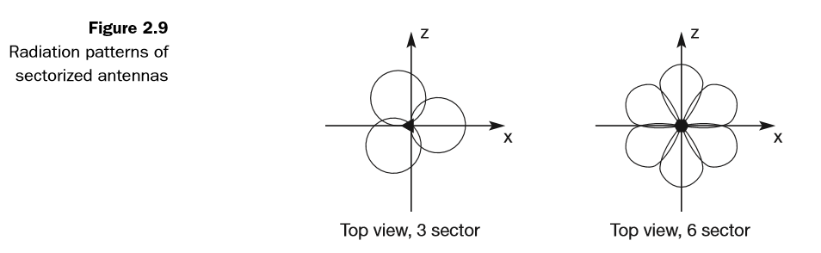

Two or more antennas can also be combined to improve reception by counteracting the negative effects of multi-path propagation. (These antennas, also called **multi-element antenna** arrays, allow different diversity schemes. One such scheme is switched diversity or selection diversity, where the receiver always uses the antenna element with the largest output. Diversity combining constitutes a combination of the power of all signals to produce gain. The phase is first corrected (co-phasing) to avoid cancellation.

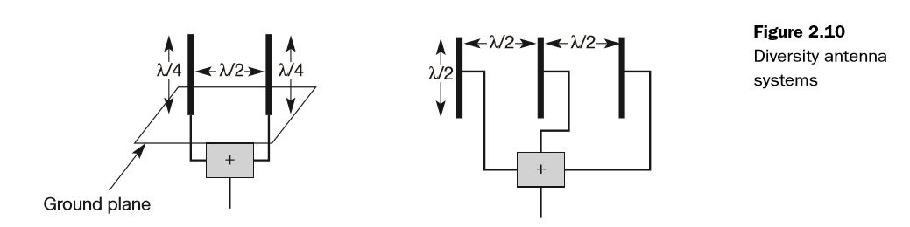

As shown in Figure 2.10, different schemes are possible. On the left, two λ/4 antennas are combined with a distance of λ/2 between them on top of a ground plane. On the right, three standard λ/2 dipoles are combined with a distance of λ/2 between them. Spacing could also be in multiples of λ/2.A more advanced solution is provided by smart antennas which combine multiple antenna elements (also called antenna array) with signal processing to optimize the radiation/reception pattern in response to the signal environment.

** Signal propagation**:

In wireless networks, the signal has no wire to determine the direction of propagation, whereas signals in wired networks only travel along the wire (which can be twisted pair copper wires, a coax cable, but also a fiber etc.). As long as the wire is not interrupted or damaged, it typically exhibits the same characteristics at each point. One can precisely determine the behavior of a signal travelling along this wire, e.g., received power depending on the length. For wireless transmission, this predictable behavior is only valid in a vacuum, i.e., without matter between the sender and the receiver.

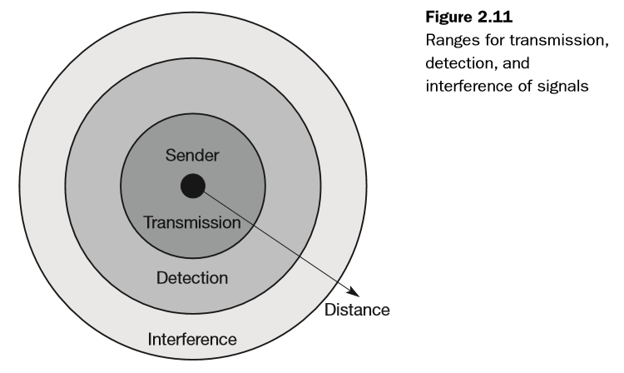

● **Transmission range**: Within a certain radius of the sender transmission is possible, i.e., a receiver receives the signals with an error rate low enough to be able to communicate and can also act as sender.

● **Detection range**: Within a second radius, detection of the transmission is possible, i.e., the transmitted power is large enough to differ from background noise. However, the error rate is too high to establish communication.

● **Interferencerange**: Within a third even larger radius, the sender may interfere with other transmission by adding to the background noise. A receiver will not be able to detect the signals, but the signals may disturb other signals.

**Path loss of radio signals**:

In free space radio signals propagate as light does (independently of their frequency), i.e., they follow a straight line (besides gravitational effects). If such a straight line exists between a sender and a receiver it is called **line-of-sight (LOS).** Even if no matter exists between the sender and the receiver (i.e., if there is a vacuum), the signal still experiences the free space loss. The received power Pr is proportional to 1/d2 with d being the distance between sender and receiver (inverse square law). While the path loss or attenuation does not cause too much trouble for short distances, e.g., for LANs the atmosphere heavily influences transmission over long distances, e.g., satellite transmission Even mobile phone systems are influenced by weather conditions such as heavy rain. Rain can absorb much of the radiated energy of the antenna (this effect is used in a microwave oven to cook), so communication links may break down as soon as the rain sets in.

Radio waves can exhibit three fundamental propagation behaviors depending on their frequency:

● **Ground wave** (<2 MHz): Waves with low frequencies follow the earth’s surface and can propagate long distances. These waves are used for, e.g., submarine communication or AM radio.

● **Sky wave** (2–30 MHz): Many international broadcasts and amateur radio use these short waves that are reflected2 at the ionosphere. This way the waves can bounce back and forth between the ionosphere and the earth’s surface, travelling around the world.

● **Line-of-sight** (>30 MHz): Mobile phone systems, satellite systems, cordless telephones etc. use even higher frequencies. The emitted waves follow a (more or less) straight line of sight. This enables direct communication with satellites (no reﬂection at the ionosphere) or microwave links on the ground. However, an additional consideration for ground-based communication is that the waves are bent by the atmosphere due to refraction

**Additional signal propagation effects**:

we rarely have a line-of-sight between the sender and receiver of radio signals. Mobile phones are typically used in big cities with skyscrapers, on mountains, inside buildings, while driving through an alley etc.

An extreme form of attenuation is blocking or shadowing of radio signals due to large obstacles .The higher the frequency of a signal, the more it behaves like light. Even small obstacles like a simple wall, a truck on the street, or trees in an alley may block the signal. If an object is large compared to the wavelength of the signal, e.g., huge buildings, mountains, or the surface of the earth, the signal is reﬂected. The reﬂected signal is not as strong as the original, as objects can absorb some of the signal’s power. Reﬂection helps transmitting signals as soon as no LOS existshere more often the signal is reﬂected, the weaker it becomes side shows the effect of refraction. 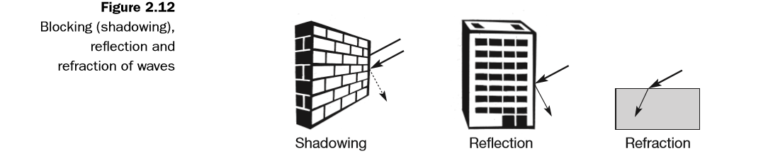

The following two effects exhibit the ‘wave’ character of radio signals.

If the size of an obstacle is in the order of the wavelength or less, then waves can be scattered

Another effect is diffraction of waves, this effect is very similar to scattering. Radio waves will be deflected at an edge and propagate in different directions. The result of scattering and diffraction are patterns with varying signal strengths depending on the location of the receiver.

Effects like attenuation, scattering, diffraction, and refraction all happen simultaneously and are frequency and time dependent. It is very difﬁcult to predict the precise strength of signals at a certain point in space.

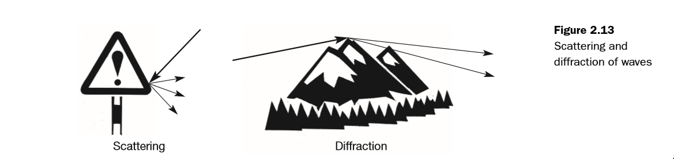

**Multi-path propagation**:

Together with the direct transmission from a sender to a receiver, the propagation effects lead to one of the most severe radio channel impairments, called multi-path propagation. Radio waves emitted by the sender can either travel along a straight line, or they may be reﬂected at a large building, or scattered at smaller obstacles.

This effect (caused by multi-path propagation) is called delay spread: the original signal is spread due to different delays of parts of the signal.

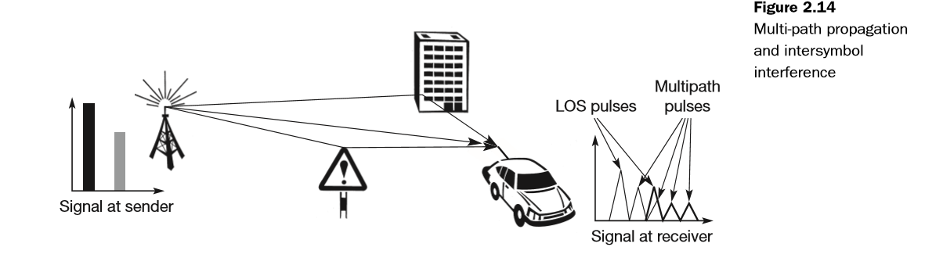

only three possible paths are shown and, thus, the impulse at the sender will result in three smaller impulses at the receiver. For a real situation with hundreds of different paths, this implies that a single impulse will result in many weaker impulses at the receiver. Each path has a different attenuation and, the received pulses have different power. Some of the received pulses will be too weak even to be detected (i.e., they will appear as noise).

. On the sender side, both impulses are separated. At the receiver, both impulses interfere, i.e., they overlap in time. Now consider that each impulse should represent a symbol, and that one or several symbols could represent a bit. The energy intended for one symbol now spills over to the adjacent symbol, an effect which is called intersymbol interference (ISI).

In this case, knowing the channel characteristics can be a great help. If the receiver knows the delays of the different paths (or at least the main paths the signal takes), it can compensate for the distortion caused by the channel. The sender may first transmit a training sequence known by the receiver. The receiver then compares the received signal to the original training sequence and programs an equalizer that compensates for the distortion

While ISI and delay spread already occur in the case of ﬁxed radio transmitters and receivers, the situation is even worse if receivers, or senders, or both, move.

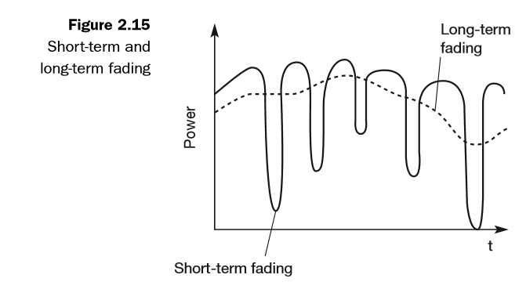

Then the channel characteristics change over time, and the paths a signal can travel along vary. This effect is well known (and audible) with analog radios while driving. The power of the received signal changes considerably over time. These quick changes in the received power are also called **short-term fading.**

An additional effect shown is the **long-term fading** of the received signal. This long-term fading, shown here as the average power over time, is caused by, for example, varying distance to the sender or more remote obstacles. Typically, senders can compensate for long-term fading by increasing/decreasing sending power so that the received signal always stays within certain limits.

**\*\*MULTIPLEXING\*\***:Multiplexing is a method by which multiple analog or digital signals are combined into one signal over a shared medium. The aim is to share an expensive resource. For example, in telecommunications, several telephone calls may be carried using one wire. Multiplexing is not only a fundamental mechanism in communication systems but also in everyday life. Multiplexing describes how several users can share a medium with minimum or no interference. Multiplexing can be carried out in four dimensions:

* Space(si)
* Time(t)
* Frequency(f)
* Code(c)

**Space division multiplexing**:

In this ﬁeld, the task of multiplexing is to assign space, time, frequency, and code to each communication channel with a minimum of interference and a maximum of medium utilization. The term communication channel here only refers to an association of sender(s) and receiver(s) who want to exchange data.

Figure 2.16 shows six channels ki and introduces a three dimensional coordinate system. This system shows the dimensions of code c, time t and frequency f. For this first type of multiplexing, space division multiplexing (SDM), the (three dimensional) space si is also shown. Here space is represented via circles indicating the interference range .The channels k1 to k3 can be mapped onto the three ‘spaces’ s1 to s3 which clearly separate the channels and prevent the interference ranges from overlapping. The space between the interference ranges is sometimes called guard space. Such a guard space is needed in all four multiplexing schemes presented.

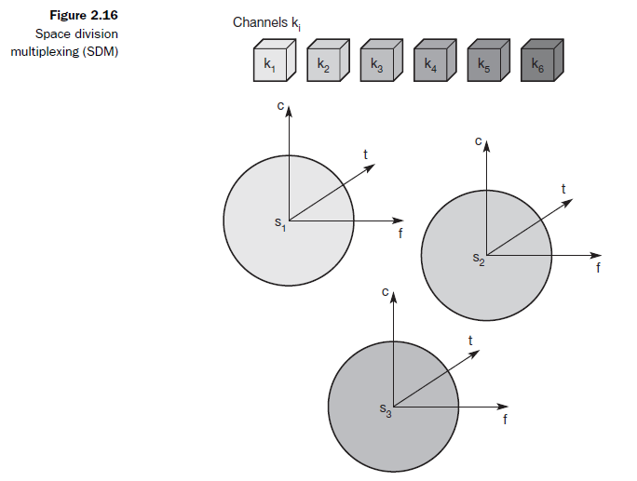

For the remaining channels (k4 to k6) three additional spaces would be needed. In our highway example this would imply that each driver had his or her own lane. Although this procedure clearly represents a waste of space, this is exactly the principle used by the old analog telephone system: each subscriber is given a separate pair of copper wires to the local exchange. In wireless transmission, SDM implies a separate sender for each communication channel with a wide enough distance between senders. This multiplexing scheme is used, for example, at FM radio stations where the transmission range is limited to a certain region many radio stations around the world can use the same frequency without interference. Using SDM, obvious problems arise if two or more channels were established within the same space, for example, if several radio stations want to broadcast in the same city. Then, one of the following multiplexing schemes must be used (frequency, time, or code division multiplexing).

**Frequency division multiplexing:**

Frequency division multiplexing (FDM) describes schemes to subdivide the frequency dimension into several non-overlapping frequency bands as shown in Figure 2.17. Each channel ki is now allotted its own frequency band as indicated. Senders using a certain frequency band can use this band continuously. Again, guard spaces are needed to avoid frequency band overlapping (also called adjacent channel interference). This scheme is used for radio stations within the same region, where each radio station has its own frequency. This very simple multiplexing scheme does not need complex coordination between sender and receiver: the receiver only has to tune in to the speciﬁc sender.

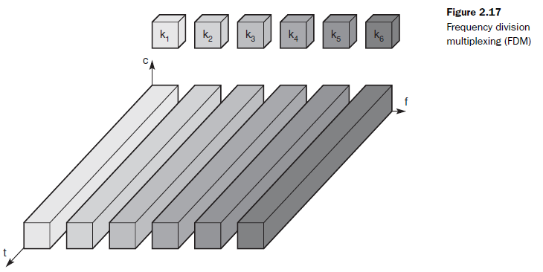

However, this scheme also has disadvantages. While radio stations broad- cast 24 hours a day, mobile communication typically takes place for only a few minutes at a time. Assigning a separate frequency for each possible communication scenario would be a tremendous waste of (scarce) frequency resources. Additionally, the ﬁxed assignment of a frequency to a sender makes the scheme very inﬂexible and limits the number of senders.

**Time division multiplexing:**

A more ﬂexible multiplexing scheme for typical mobile communications is time division multiplexing (TDM). Here a channel ki is given the whole bandwidth for a certain amount of time, i.e., all senders use the same frequency but at different points in time (see Figure 2.18). Again, guard spaces, which now represent time gaps, have to separate the different periods when the senders usethe medium. In our highway example, this would refer to the gap between twocars. If two transmissions overlap in time, this is called co-channel interference.(In the highway example, interference between two cars results in an accident.) To avoid this type of interference, precise synchronization between different senders is necessary. This is clearly a disadvantage, as all senders need precise clocks or, alternatively, a way has to be found to distribute a synchronization signal to all senders. For a receiver tuning in to a sender this does not just involve adjusting the frequency, but involves listening at exactly the right point in time. However, this scheme is quite ﬂexible as one can assign more sendingtime to senders with a heavy load and less to those with a light load.

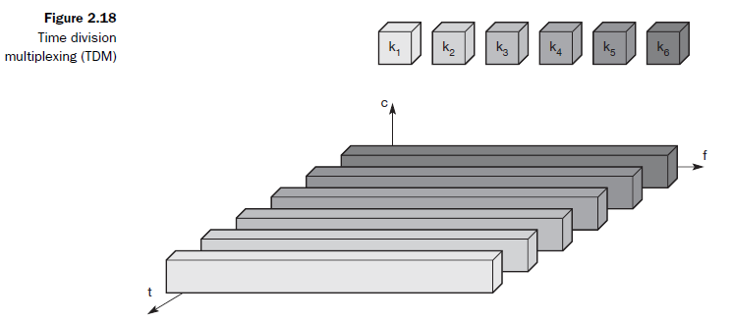

**Frequency and time division multiplexing can be combined**, i.e., a channel ki can use a certain frequency band for a certain amount of time as shown in Figure 2.19. Now guard spaces are needed both in the time and in the frequency dimension. This scheme is more robust against frequency selective interference, i.e., interference in a certain small frequency band. A channel may use this band only for a short period of time. Additionally, this scheme provides some (weak) protection against tapping, as in this case the sequence of frequencies a sender uses has to be known to listen in to a channel. The mobile phone standard GSM uses this combination of frequency and time division multiplexing for transmission between a mobile phone and a so-called base station.

A disadvantage of this scheme is again the necessary coordination between different senders. One has to control the sequence of frequencies and the time of changing to another frequency. Two senders will interfere as soon as they select the same frequency at the same time. However, if the frequency change (also called frequency hopping) is fast enough, the periods of interference may be so small that, depending on the coding of data into signals, a receiver canstill recover the original data.

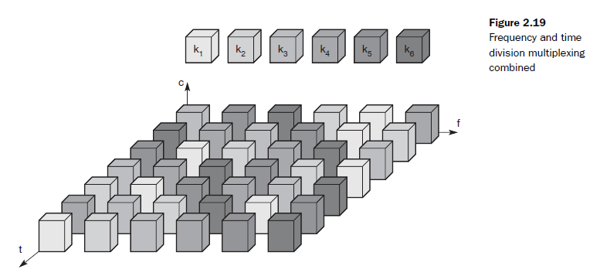

**Code division multiplexing:**

While SDM and FDM are well known from the early days of radio transmission and TDM is used in connection with many applications, code division multiplexing (CDM) is a relatively new scheme in commercial communication systems. First used in military applications due to its inherent security features. Figure 2.20 shows how all channels ki use the same frequency at the same time for transmission. Separation is now achieved by assigning each channel its own ‘code’, guard spaces are realized by using codes with the necessary ‘distance’ in code space, e.g., orthogonal codes.

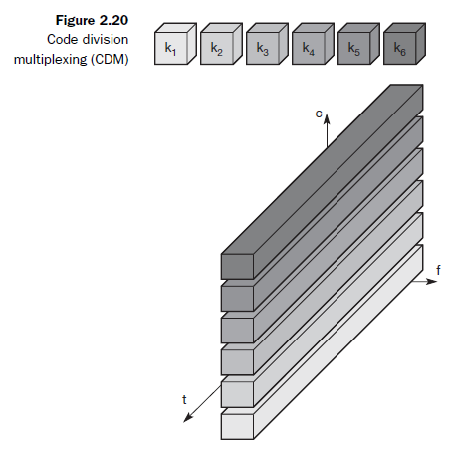

The main advantage of CDM for wireless transmission is that it gives good protection against interference and tapping. Different codes have to be assigned, but code space is huge compared to the frequency space. Assigning individual codes to each sender does not usually cause problems. The main disadvantage of this scheme is the relatively high complexity of the receiver. A receiver has to know the code and must separate the channel with user data from the background noise composed of other signals and environmental noise. Additionally, a receiver must be precisely synchronized with the transmitter to apply the decoding correctly. The voice example also gives a hint to another problem of CDM receivers. All signals should reach a receiver with almost equal strength, otherwise some signals could drain others. If some people close to a receiver talk very loudly the language does not matter. The receiver cannot listen to any other person. To apply CDM, precise power control is required.

** MODULATION** :

Modulation is the addition of information to an electronic or optical carrier signal.(or)  **Modulation** is the process of varying one or more properties of a periodic waveform, called the carrier signal, with a **modulating** signal that typically contains information to be transmitted.

A carrier signal is one with a steady waveform,constant height(amplitude) and frequency.

g(t) = Atcos(2πft + φt)

This function has three parameters: amplitude ‘At’ frequency ‘ft’ and phase ‘φt’. which may be varied in accordance with data or another modulating signal. Fordigital modulation, digital data (0 and 1)is translated into an analog signal (base band signal). Digital modulation is required if digital data has to be transmitted over a medium that only allows for analog transmission.There are four modulation techniques.They are:

* Digital to Digital
* Digital to Analog
* Analog to Digital
* Analog to Analog

In wireless networks, however, digital transmission cannot be used. Here, the binary bit-stream has to be translated into an Analog signal ﬁrst (Digital to Analog).The three basic methods for this translation are:

* amplitude shift keying (ASK)
* frequency shift keying (FSK), and
* Phase shift keying (PSK).

Amplitude shift keying:Amplitude shift keying (ASK), the most simple digital modulation scheme. The two binary values, 1 and 0, are represented by two different amplitudes. In the example, one of the amplitudes is 0 (representing the binary 0).

This simple scheme only requires low bandwidth, but is very susceptible to interference. Effects like multi-path propagation, noise, or path lossheavily inﬂuence the amplitude. In a wireless environment, a constant amplitudecannot be guaranteed, so ASK is typically not used for wireless radio transmission. However, the wired transmission scheme with the highest performance, namely optical transmission, uses ASK. Here, a light pulse may represent a 1, while theabsence of light represents a 0. The carrier frequency in optical systems is some hundred THz. ASK can also be applied to wireless infra-red transmission, using a directed beam or diffuse light .

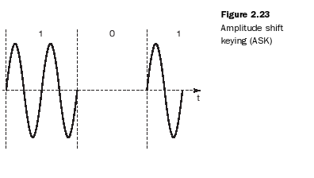

Frequency shift keying:

A modulation scheme often used for wireless transmission is frequency shiftkeying (FSK) . The simplest form of FSK, also called binary FSK(BFSK), assigns one frequency f1 to the binary 1 and another frequency f2 to the binary 0. A very simple way to implement FSK is to switch between two oscillators, one with the frequency f1 and the other with f2 depending on the input. To avoid sudden changes in phase, special frequency modulators with continuous phase modulation, (CPM)can be used. Sudden changes in phase cause high frequencies, which is an undesired side-effect.A simple way to implement demodulation is by using two band-pass ﬁlters,one for f1 the other for f2. A comparator can then compare the signal levels ofthe ﬁlter outputs to decide which of them is stronger. FSK needs a larger band-width compared to ASK but is much less susceptible to errors.

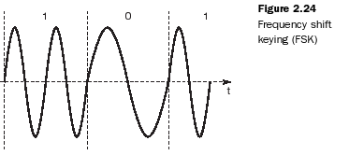

Phase shift keying:

Finally, phase shift keying (PSK) uses shifts in the phase of a signal to represent data. Figure 2.25 shows a phase shift of 180° or π as the 0 follows the 1 (the same happens as the 1 follows the 0). This simple scheme, shifting the phase by 180° each time the value of data changes, is also called binary PSK (BPSK). A simpleimplementation of a BPSK modulator could multiply a frequency f with +1 ifthe binary data is 1 and with –1 if the binary data is 0.To receive the signal correctly, the receiver must synchronize in frequency and phase with the transmitter. This can be done using a phase lock loop (PLL). Compared to FSK, PSK is more resistant to interference, but receiver and transmitter are also more complex.

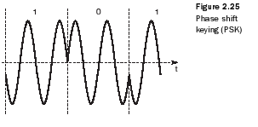

**Analog to Digital:**

There are two different modulations: They are:Pulse Amplitude modulation(PAM)

and Pulse Code Modulation(PCM).

**Analog to Analog:**

As for digital modulation, three different basic schemes are known for

analog modulation: amplitude modulation (AM), frequency modulation

(FM), and phase modulation (PM).

**Advanced frequency shift keying**

A famous FSK scheme used in many wireless systems is minimum shift keying (MSK). MSK is basically BFSK without abrupt phase changes, i.e., it belongs to CPM schemes. Figure shows an example for the implementation of MSK. In a first step, data bits are separated into even and odd bits, the duration of each bit being doubled. The scheme also uses two frequencies: f1, the lower frequency, and f2, the higher frequency, with f2 = 2f1.

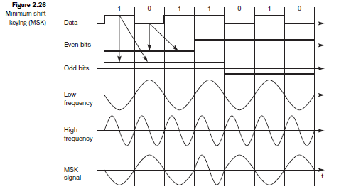

According to the following scheme, the lower or higher frequency is chosen (either inverted or non-inverted) to generate the MSK signal:

● if the even and the odd bit are both 0, then the higher frequency f2 is inverted (i.e., f2 is used with a phase shift of 180°);

● if the even bit is 1, the odd bit 0, then the lower frequency f1 is inverted. This is the case, e.g., in the fifth to seventh columns of Figure.

● if the even bit is 0 and the odd bit is 1, as in columns 1 to 3, f1 is taken without changing the phase,

● if both bits are 1 then the original f2 is taken.

A high frequency is always chosen if even and odd bits are equal. The signal is inverted if the odd bit equals 0. This scheme avoids all phase shifts in the resulting MSK signal. Adding a so-called Gaussian low-pass filter to the MSK scheme results in Gaussian MSK (GMSK), which is the digital modulation scheme for many European wireless standards. The filter reduces the large spectrum needed by MSK.

**Advanced phase shift keying**

The simple PSK scheme can be improved in many ways. The basic BPSK scheme only uses one possible phase shift of 180°. The left side of Figure 2.27 shows BPSK in the phase domain.

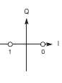(fig 2.27)

(Fig 2.29) shows Quadrature PSK (QPSK) in phase domain, one of the most common PSK schemes (sometimes also called quaternary PSK). Here, higher bit rates can be achieved for the same bandwidth by coding two bits into one phase shift. Alternatively, one can reduce the bandwidth and still achieve the same bit rates as for BPSK.

QPSK (and other PSK schemes) can be realized in two variants. The phase shift can always be relative to a reference signal (with the same frequency). If this scheme is used, a phase shift of 0 means that the signal is in phase with the reference signal. A QPSK signal will then exhibit a phase shift of 45° for the data 11, 135° for 10, 225° for 00, and 315° for 01 – with all phase shifts being relative to the reference signal. The transmitter ‘selects’ parts of the signal as shown in Figure and concatenates them. To reconstruct data, the receiver has to compare the incoming signal with the reference signal. One problem of this scheme involves producing a reference signal at the receiver. Transmitter and receiver have to be synchronized very often, e.g., by using special synchronization patterns before user data arrives or via a pilot frequency as reference.

(fig 2.29) 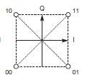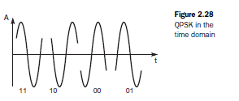

**\*\*Spread spectrum**:**

As the name implies, spread spectrum techniques involve spreading the bandwidth needed to transmit data. The main advantage is the resistance to narrowband interference.

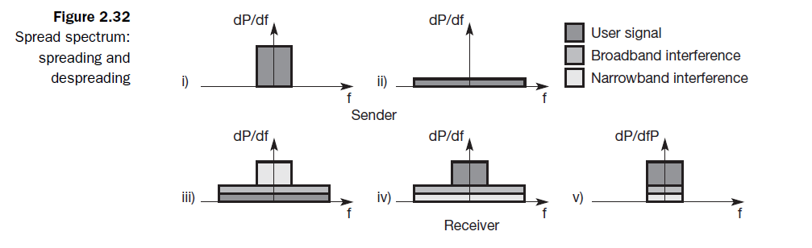

1. Shows an idealized narrowband signal from a sender of user data.
2. Converts the narrowband signal into a broadband signal. The narrowband signal into a broadband signal.The energy needed to transmitthe signal (the area shown in the diagram) is the same, but it is now spread overa larger frequency range. The power level of the spread signal can be much lowerthan that of the original narrowband signal without losing data. Depending onthe generation and reception of the spread signal, the power level of the usersignal can even be as low as the background noise. This makes it difficult to distinguishthe user signal from the background noise and thus hard to detect
3. The sum of interference and user signal is received. Thereceiver now knows how to de-spread the signal, converting the spread usersignal into a narrowband signal again.
4. The receiver applies a band-pass filter to cut off frequencies left and right of the narrowband signal. Finally, the receiver can reconstruct the original data because the power level of the user signal is high enough, i.e., the signal is much stronger than the remaining interference.

Just as spread spectrum helps to deal with narrowband interference for a single channel, it can be used for several channels. Consider the situation shown in Figure 2.33. Six different channels use FDM for multiplexing, which means that each channel has its own narrow frequency band for transmission. Between each frequency band a guard space is needed to avoid adjacent channel interference and this method requires careful frequency planning.

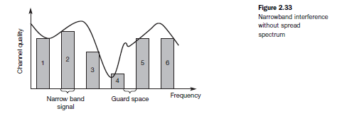

Depending on receiver characteristics, channels 1, 2, 5, and 6 could be received while the quality of channels 3 and 4 is too bad to reconstruct transmitted data. Narrowband interference destroys the transmission of channels 3 and 4.

Spread spectrum can increase resistance to narrowband interference. The same technique is now applied to all narrowband signals. As shown in Figure 2.34, all narrowband signals are now spread into broadband signals using the same frequency range. No more frequency planning is needed (under these simplified assumptions), and all senders use the same frequency band. But how can receivers recover their signal?

To separate different channels, CDM is now used instead of FDM. This application shows the tight coupling of CDM and spread spectrum. Each channel is allotted its own code, which the receivers have to apply to recover the signal. Without knowing the code, the signal cannot be recovered and behaves like background noise. This is the security effect of spread spectrum if a secret code is used for spreading. Features that make spread spectrum and CDM very attractive for military applications are the coexistence of several signals without coordination (apart from the fact that the codes must have certain properties), robustness against narrowband interference, relative high security, and a characteristic like background noise. Only the appropriate (secret) codes have to be exchanged.

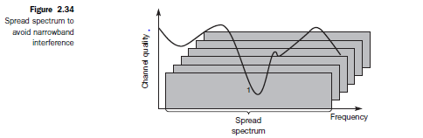

Apart from military uses, the combination of spread spectrum and CDM is becoming more and more attractive for everyday applications. This was used in US mobile systems.

**Spread Spectrum Draw backs:**

* One disadvantage isthe increased complexity of receivers that have to de-spread a signal.
* Another problem is the large frequency band that is needed due to thespreading of the signal. Although spread signals appear more like noise, theystill raise the background noise level and may interfere with other transmissionsif no special precautions are takenn

**Spread spectrum can be achieved in two ways:**

* **DSSS**
* **FHSS**

***\*DSSS***

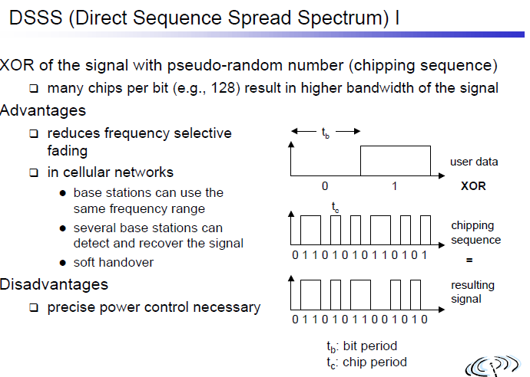

**DSSS transmitter and receiver structures:**

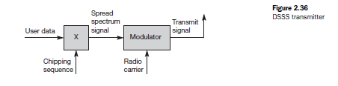

The first step in a DSSS transmitter, Figure 2.36 is the spreading of the user data with the chipping sequence (digital modulation). The spread signal is then modulated with a radio carrier.

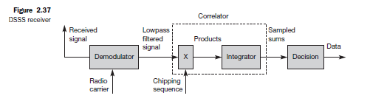

The DSSS receiver is more complex than the transmitter. The receiver onlyhas to perform the inverse functions of the two transmitter modulation steps. However, noise and multi-path propagation require additional mechanisms to reconstruct the original data. The first step in the receiver involves demodulating the received signal. This is achieved using the same carrier as the transmitter reversing the modulation and results in a signal with approximately the same bandwidth as the original spread spectrum signal. Additional filtering can be applied to generate this signal.

While demodulation is well known from ordinary radio receivers, the next steps constitute a real challenge for DSSS receivers, contributing to the complexity of the system. The receiver has to know the original chipping sequence, i.e., the receiver basically generates the same pseudo random sequence as the transmitter. Sequences at the sender and receiver have to be precisely synchronized

because the receiver calculates the product of a chip with the incoming signal. This comprises another XOR operation together with a medium access mechanism that relies on this scheme. During a bit period, which also has to be derived via synchronization, an integrator adds all these products. Calculating the products of chips and signal, and adding the products in an integrator is also called correlation, the device a correlator. Finally, in each bit period a decision unit samples the sums generated by the integrator and decides if this sum represents a binary 1 or a 0. Thus receiver section work is completed.

***\*FHSS:***

For frequency hopping spread spectrum (FHSS) systems, the total available bandwidth is split into many channels of smaller bandwidth plus guard spaces between the channels. Transmitter and receiver stay on one of these channels for a certain time and then hop to another channel. This system implements FDM and TDM. The pattern of channel usage is called the hopping sequence,

the time spend on a channel with a certain frequency is called the dwell time. FHSS comes in two variants, slow and fast hopping (see Figure 2.38).

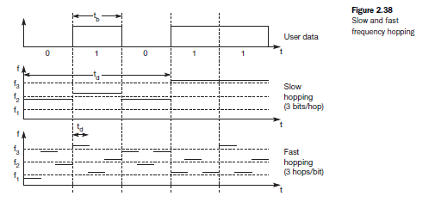

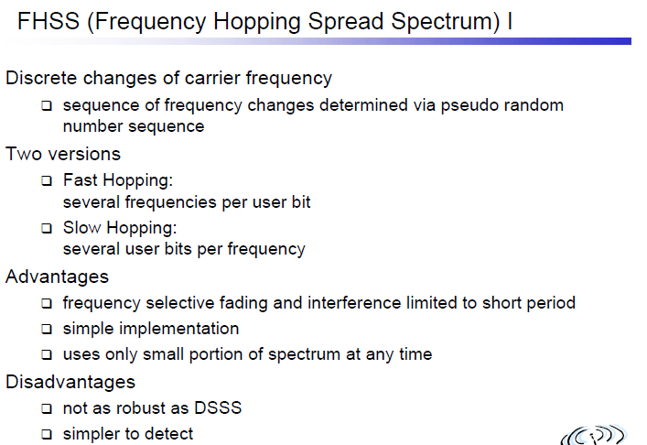

**FHSS transmitter and receiver structures:**

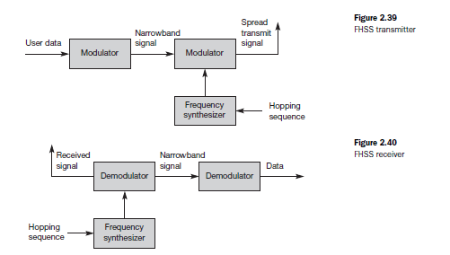

**Comparison between DSSS and FHSS:**

Compared to DSSS, spreading is simpler using FHSS systems. FHSS systems only use a portion of the total band at any time, while DSSS systems always use the total bandwidth available. DSSS systems on the other hand are more resistant to fading and multi-path effects. DSSS signals are much harder to detect without knowing the spreading code, detection is virtually impossible.

**Chapter-3 MEDIA ACCESS CONTROL:**

The Media Access Control (MAC) data communication protocol sub-layer, also known as the

Medium Access Control, is a sub-layer of the Data Link Layer specified in the seven-layer OSI

model (layer 2). The hardware that implements the MAC is referred to as a Medium Access

Controller. The MAC sub-layer acts as an interface between the Logical Link Control (LLC)

Sub-layer and the network's physical layer. The MAC layer emulates a full-duplex logical

communication channel in a multi-point network. This channel may provide unicast, multicast or

broadcast communication service.

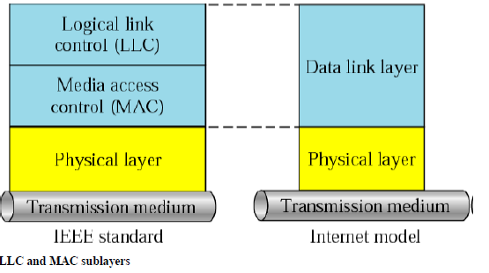

**Motivation for a specialized MAC**

One of the most commonly used MAC schemes for wired networks **is carrier sense multiple access with collision detection** (CSMA/CD). In this scheme, a sender senses the medium (a wire

or coaxial cable) to see if it is free. If the medium is busy, the sender waits until it is free. If the

medium is free, the sender starts transmitting data and continues to listen into the medium. If the

sender detects a collision while sending, it stops at once and sends a jamming signal. But this

scheme doesn’t work well with wireless networks. The problems are:

• Signal strength decreases proportional to the square of the distance

• The sender would apply CS and CD, but the collisions happen at the receiver

• It might be a case that a sender cannot “hear” the collision, i.e., CD does not work

Furthermore, CS might not work, if for e.g., a terminal is “hidden”.

**Hidden and Exposed Terminals**

Consider the scenario with three mobile phones as shown below. The transmission range of A

reaches B, but not C (the detection range does not reach C either). The transmission range of C

reaches B, but not A. Finally, the transmission range of B reaches A and C, i.e., A cannot detect

C and vice versa.

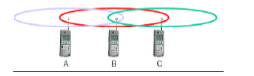

**Hidden terminals**

• A sends to B, C cannot hear A

• C wants to send to B, C senses a “free” medium (CS fails) and starts transmitting

• Collision at B occurs, A cannot detect this collision (CD fails) and continues with its

transmission to B

• A is “hidden” from C and vice versa

**Exposed terminals**

• B sends to A, C wants to send to another terminal (not A or B) outside the range

• C senses the carrier and detects that the carrier is busy.

• C postpones its transmission until it detects the medium as being idle again

• but A is outside radio range of C, waiting is not necessary

• C is “exposed” to B

Hidden terminals cause collisions, where as Exposed terminals causes unnecessary delay.

**Near and far terminals**

Consider the situation shown below. A and B are both sending with the same transmission

power.

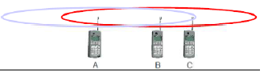

• Signal strength decreases proportional to the square of the distance

• So, B’s signal drowns out A’s signal making C unable to receive A’s transmission

• If C is an arbiter for sending rights, B drown out A’s signal on the physical layer making

C unable to hear out A.

The near/far effect is a severe problem of wireless networks using CDM. All signals should

arrive at the receiver with more or less the same strength for which Precise power control is to be

implemented.

**SDMA**

Space Division Multiple Access (SDMA) is used for allocating a separated space to users in wireless networks. A typical application involves assigning an optimal base station to a mobile

phone user. The mobile phone may receive several base stations with different quality. A MAC

algorithm could now decide which base station is best, taking into account which frequencies

(FDM), time slots (TDM) or code (CDM) are still available. The basis for the SDMA algorithm

is formed by cells and sectorized antennas which constitute the infrastructure implementing

space division multiplexing (SDM). SDM has the unique advantage of not requiring any

multiplexing equipment. It is usually combined with other multiplexing techniques to better

utilize the individual physical channels.

**FDMA**

Frequency division multiplexing (FDM) describes schemes to subdivide the frequency dimension into several non-overlapping frequency bands.

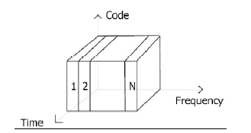

Frequency Division Multiple Access is a method employed to permit several users to transmit simultaneously on one satellite transponder by assigning a specific frequency within the channel to each user. Each conversation gets its own, unique, radio channel. The channels are relatively narrow, usually 30 KHz or less and are defined as either transmit or receive channels. A full duplex conversation requires a transmit& receive channel pair. FDM is often used for simultaneous access to the medium by base station and mobile station in cellular networks establishing a duplex channel. A scheme called **frequency division duplexing (FDD)** in which the two directions, mobile station to base station and vice versa are now separated using different frequencies.

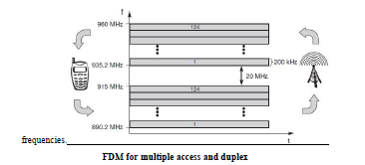

The two frequencies are also known **as uplink,** i.e., from mobile station to base station or from ground control to satellite, and **as downlink**, i.e., from base station to mobile station or fromsatellite to ground control. The basic frequency allocation scheme for GSM is fixed andregulated by national authorities. All uplinks use the band between 890.2 and 915 MHz, all downlinks use 935.2 to 960 MHz. According to FDMA, the base station, shown on the right side, allocates a certain frequency for up- and downlink to establish a duplex channel with a mobile phone. Up- and downlink have a fixed relation. If the uplink frequency is fu = 890 MHz + n·0.2

MHz, the downlink frequency is fd = fu + 45 MHz, i.e.,fd = 935 MHz + n·0.2 MHz for a certain channel n. The base station selects the channel. Each channel (uplink and downlink) has a bandwidth of 200 kHz.

This scheme also has disadvantages. While radio stations broadcast 24 hours a day, mobile communication typically takes place for only a few minutes at a time. Assigning a separate frequency for each possible communication scenario would be a tremendous waste of (scarce) frequency resources. Additionally, the fixed assignment of a frequency to a sender makes the scheme very inflexible and limits the number of senders.

**TDMA**

A more flexible multiplexing scheme for typical mobile communications is time division multiplexing (TDM).

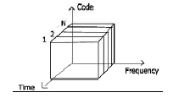

Compared to FDMA, time division multiple access (TDMA) offers a much more flexible scheme, which comprises all technologies that allocate certain time slots for communication. Now synchronization between sender and receiver has to be achieved in the time domain. Again this can be done by using a fixed pattern similar to FDMA techniques, i.e., allocating a certain time slot for a channel, or by using a dynamic allocation scheme. Listening to different frequencies at the same time is quite difficult, but listening to many channels separated in time at the same frequency is simple. Fixed schemes do not need identification, but are not as flexible considering varying bandwidth requirements.

**Fixed TDM:**

The simplest algorithm for using TDM is allocating time slots for channels in a fixed pattern.

This results in a fixed bandwidth and is the typical solution for wireless phone systems. MAC is

quite simple, as the only crucial factor is accessing the reserved time slot at the right moment. If

this synchronization is assured, each mobile station knows its turn and no interference will

happen. The fixed pattern can be assigned by the base station, where competition between

different mobile stations that want to access the medium is solved.

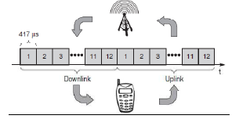

The above figure shows how these fixed TDM patterns are used to implement multiple access and a duplex channel between a base station and mobile station. Assigning different slots for

uplink and downlink using the same frequency is called time division duplex (TDD). As shown

in the figure, the base station uses one out of 12 slots for the downlink, whereas the mobile

station uses one out of 12 different slots for the uplink. Uplink and downlink are separated in

time. Up to 12 different mobile stations can use the same frequency without interference using

this scheme. Each connection is allotted its own up- and downlink pair. This general scheme still

wastes a lot of bandwidth. It is too static, too inflexible for data communication. In this case,

connectionless, demand-oriented TDMA schemes can be used

